Email – Narendra.e16202@cumail.in, Hitesh.e16378@cumail.in, sangita.e16523@cumail.in, ankit.e16400@cumail.in, poulabi.e16365@cumail.in.

INVENTOR DETAIL:

NAME: HIMANSHU GUPTA
EMAILID: gupta.himanshu1097@gmail.com
MOBILE NO: 8271697622
DESIGNATION AND DEPARTMENT: Department of Electronics and Communication Engineering
SCANNED HAND SIGNATURE:

OTHER INVENTOR DETAIL:
NAME: MRADUL SHANKRAT
EMAILID: mradulshankrat26@gmail.com
MOBILE NO: 9005356930
DESIGNATION AND DEPARTMENT: Department of Electronics and Communication Engineering
SCANNED HAND SIGNATURE:

NAME: Raj
EMAILID: technologys411@gmail.com
MOBILE NO: 6387287539
DESIGNATION AND DEPARTMENT: Department of Electronics and Communication Engineering

A) Please enlist the Key concepts and terms/Keywords/Synonyms used in the Invention?
S. No | Keywords for invention which must be search | Synonyms
1 | Evacuation | Emergency relocation, displacement, exodus
2 | Shelter | Haven, refuge, sanctuary
3 | Smart Shelter | Intelligent shelter, technology-enabled shelter
4 | Real-time Occupancy | Live capacity tracking, dynamic occupancy monitoring
5 | Resource Management | Supply allocation, aid distribution
6 | Information Kiosk | Self-serve station, information hub
7 | Disaster Response | Emergency management, crisis mitigation
8 | Sensor Network | IoT System, connected sensors
9 | Data-driven | Data-informed, data-enabled

Written Description - Invention Information

1. TITLE OF INVENTION- 15 words max

ShelterLink: Enhancing Evacuation Efficiency with Smart Shelters

2. BACKGROUND OF THE INVENTION- prior art search, tell what the problem in past and how your invention was overcome it. Compare your invention with closet prior art.

Evacuations during disasters can be incredibly chaotic, leaving people scrambling to find safe havens. Shelters, intended to provide a safe refuge, can become overwhelmed by sheer numbers. This overcrowding creates cramped and unsanitary conditions. As resources become stretched thin, necessities like food, water, and sanitation become scarce, adding to the stress of those seeking shelter.

Making matters worse, evacuees often lack crucial information about available resources and assistance programs. This information gap leaves them feeling even more vulnerable during a crisis. The combination of these issues creates a stressful and risky environment for people already dealing with the trauma of a disaster. Clearly, innovative solutions are urgently needed to improve the evacuation process and ensure the safety and well-being of everyone affected.

Imagine a disaster strike, and the usual chaos of finding shelter is transformed. A brand-new invention shines as a beacon of hope, offering a complete solution for evacuees facing uncertainty and danger.

Smarter Shelters: Forget the mad dash to overflowing shelters. This invention uses a cutting-edge app or website to connect evacuees with real-time information on available shelters and how many people they can hold. No more overcrowded buildings – people can make informed choices about where to go for safety.

Resource Rescue: This isn't just about finding a roof. The invention works with aid groups to get essential supplies like food, water, and medical care to the shelters that need them most. This ensures everyone gets a fair share, even when things get tough.

Empowering Knowledge: Feeling lost and confused during a disaster is terrifying. This invention acts as a central information hub, giving evacuees the latest updates on rescue efforts, nearby medical facilities, and government assistance programs. With this knowledge, evacuees can navigate the challenges of being displaced with more confidence and strength.

Leaving the Old Ways Behind-

Overwhelmed Shelters: Brick-and-mortar shelters are heroes, but they can't always handle massive disasters. People end up crammed together, and resources run low. This invention aims to do better.

Limited Information: Imagine relying on flyers or loudspeakers for crucial updates during a crisis. These methods are slow and unreliable, leaving people confused and unsure. This invention offers a faster, more dependable way to get information.

Why This Invention is Different?

Picture the chaos of an evacuation: scrambling families, overflowing shelters, and a constant worry about finding a haven. This is the reality many evacuees face. Shelters can quickly become overcrowded, leading to cramped and unsanitary conditions. With limited resources like food and water stretched thin, stress and anxiety run high.

What if there was a better way?

Enter the "Smart Shelter" Network! This innovative approach tackles the challenges of traditional shelters by harnessing the power of technology (the Internet of Things, or IoT).
Here's how it transforms the evacuation experience-

Real-time Occupancy: Imagine sensors in each shelter that count people as they come and go. This real-time data lets disaster management teams see which shelters have space and direct evacuees accordingly. No more aimlessly wandering in search of a place to stay.

Smarter Resource Management: Forget waiting for supplies to trickle down from a central hub. The "Smart Shelter" Network collects data on resource needs from each shelter. This allows for targeted allocation of food, water, and other essentials, ensuring everyone gets what they need, when they need it.

Information at Your Fingertips: Imagine self-serve kiosks inside shelters where evacuees can access up-to-date information. These kiosks can display shelter capacity, available resources, and even local updates. No more confusion or feeling out of the loop – evacuees are empowered with the knowledge they need to make informed choices.

Compared to traditional shelters, the "ShelterLink" Network offers a significant leap forward. Traditional shelters are limited by their capacity and rely on slow, manual methods to manage resources and communication. Smart Shelters, on the other hand, can be designed to be scalable and leverage data to make proactive decisions. Information kiosks empower evacuees, reducing stress and anxiety during a difficult time. The "Smart Shelter" Network isn't just about technology – it's about creating a more informed, efficient, and ultimately safer evacuation process for everyone involved.

3. BRIEF SUMMARY OF INVENTION

Imagine the harrowing scenes of a disaster unfolding. The news blares warnings, and the familiar comfort of your home suddenly feels threatened. Evacuation orders flash across the screen, and the scramble for shelter begins. Traditionally, this has meant crowded rooms, long lines, and a gnawing uncertainty about the most basic needs – a safe place to sleep, clean water to drink, and fresh air to breathe.

But what if the future of emergency shelters looked different? Enter ShelterLink, a revolutionary network poised to transform these havens into sanctuaries of safety and organization, especially during the most challenging public health crises like pandemics.

ShelterLink isn't just about putting a roof over evacuees' heads. It's a complete reimagining of the shelter experience, prioritizing both physical and mental well-being. Forget the cramped conditions that exacerbate anxiety and heighten the risk of illness. ShelterLink utilizes designated spaces to ensure proper social distancing, creating a sense of security and preventing the spread of airborne diseases. But ShelterLink doesn't stop spatial planning. Cutting-edge ventilation systems become lifelines, constantly circulating clean air, a vital safeguard against respiratory threats that loom large during pandemics. Gone are the days of stale, stuffy shelters – ShelterLink ensures a fresh, healthy environment for all.

Moving inside, efficiency becomes the watchword. Self-serve stations streamline the check-in process, eliminating long lines and the added stress of waiting. These stations become your information hub, providing clear and up-to-date details on the resources available – food, water, sanitation facilities – everything you need to feel prepared and in control. However, ShelterLink goes beyond basic information displays. Smart sensors constantly monitor temperature and humidity, ensuring everyone's comfort during a stressful time. But these sensors play a more crucial role – they keep track of occupancy in real-time.

ShelterLink isn't just about technology – it's about people. By reducing stress and confusion for evacuees, ensuring everyone has access to essential resources, and empowering disaster response teams with real-time data, ShelterLink paves the way for a more humane and efficient evacuation experience. It's a testament to the power of technology, when used thoughtfully, to make a real difference in the face of crisis. ShelterLink envisions a future where emergencies don't have to be synonymous with chaos. It's a future where technology and human compassion come together to create a network of safe havens, ensuring the well-being of everyone facing the challenges of a disaster.

4. OBJECTIVE OF THE INVENTION

As an engineering student with a passion for social impact, I've been fascinated by the challenges of disaster evacuations. Crowded shelters, resource scarcity, and limited information create a chaotic environment for evacuees and a logistical nightmare for disaster response teams. My invention, ShelterLink, aims to address these issues by transforming traditional shelters into smart, data-driven havens.

The core objective of ShelterLink is trifold:

Prioritizing Evacuee Health and Well-being: Unlike conventional shelters, ShelterLink prioritizes public health through real-time air quality monitoring. This is especially crucial during pandemics, where proper ventilation is critical to prevent the spread of airborne illnesses. Additionally, designated areas within the shelters ensure proper social distancing, minimizing the risk of infection and fostering a sense of security.

Optimizing Resource Allocation: Managing resources like food, water, and medical supplies during an evacuation can be a logistical nightmare. ShelterLink addresses this by employing smart sensors that track shelter occupancy in real-time. This data feeds into a central network, providing disaster response teams with a comprehensive picture of shelter needs. This allows for proactive resource allocation, ensuring supplies are directed to the shelters with the highest demand, leading to a more equitable distribution of aid.

Empowering Evacuees with Information: Imagine the anxiety of arriving at a shelter with limited information on resources or available space. ShelterLink tackles this by equipping shelters with self-serve kiosks. These kiosks provide evacuees with real-time updates on available resources, shelter capacity, and even local news and updates. This empowers evacuees to make informed decisions about their well-being during a stressful time.

The beauty of ShelterLink lies in its simplicity and scalability. The sensor network can be easily integrated into existing shelters, while the user interface of the kiosks can be adapted for multilingual communication. This ensures ShelterLink can be readily deployed in diverse situations.

5. EXPLAIN PROBLEMS IN PRIOR ART OR EARLIER INVENTION WHICH YOUR PRESENT INVENTION TARGET TO SOLVE POINTWISE.
Here are the key problems in prior art or earlier inventions that the present ShelterLink invention aims to solve:

1. Overcrowding in shelters: Traditional shelters often get overwhelmed during large-scale evacuations, leading to cramped and unsanitary conditions that can exacerbate stress and increase the risk of disease transmission.

2. Resource scarcity and uneven distribution: With limited resources like food, water, and medical supplies, conventional shelters struggle to allocate them effectively based on real-time needs, resulting in shortages in some places and waste in others.

3. Lack of information and communication: Evacuees arriving at traditional shelters often have limited information about available resources, shelter capacity, assistance programs, and updates on the disaster situation, leaving them feeling confused and anxious.

4. Public health risks: Conventional shelters may lack adequate ventilation systems and measures to enforce social distancing, increasing the risk of airborne disease transmission, which can be particularly dangerous during pandemics.

5. Inefficient management and coordination: Without real-time data and a centralized system, disaster response teams face challenges in efficiently managing and coordinating shelter operations, resource allocation, and evacuee needs across multiple locations.

6. Limited scalability and adaptability: Many existing shelter solutions are designed for specific locations or scenarios, making them less scalable and adaptable to different types of disasters, geographic regions, or cultural contexts.

The ShelterLink invention aims to address these problems by leveraging technology, data-driven decision-making, and a network-based approach to create smart, efficient, and safe shelters that prioritize evacuee well-being, optimize resource allocation, and improve overall disaster response coordination.

5.NOVEL ASPECTS OF THE INVENTION (Point out the new parts used in the invention which make it different from the other existing inventions or prior arts).

The ShelterLink invention incorporates several novel aspects that differentiate it from existing inventions or prior art in the field of disaster shelters and evacuation management:

1. Smart Sensor Network: The use of an interconnected network of sensors within shelters to monitor real-time occupancy, temperature, humidity, and air quality is a novel aspect. This sensor data provides valuable insights for efficient resource allocation and maintaining healthy shelter conditions.

2. Centralized Data-driven Management: The invention employs a centralized system that collects and analyzes data from multiple shelter locations. This data-driven approach enables proactive decision-making, resource optimization, and improved coordination among disaster response teams, which is a significant improvement over traditional manual and decentralized methods.

3. Self-serve Information Kiosks: The integration of self-serve kiosks within shelters is a novel feature that empowers evacuees by providing them with up-to-date information on available resources, shelter capacity, local updates, and assistance programs. This addresses the problem of lack of communication and information faced in conventional shelters.

4. Prioritization of Public Health Measures: The invention's emphasis on incorporating pandemic-specific measures like designated social distancing areas and advanced ventilation systems to maintain air quality is a novel aspect. This proactive approach to public health is crucial during infectious disease outbreaks and sets ShelterLink apart from existing shelter solutions.

5. Scalable and Adaptable Design: The modular and network-based architecture of ShelterLink allows for scalability and adaptability to different disaster scenarios, geographic regions, and cultural contexts, making it a more versatile solution compared to location-specific or inflexible shelter systems.

6. Integration of IoT and Smart Technology: The seamless integration of Internet of Things (IoT) technology, smart sensors, and data analytics into shelter management is a novel aspect that leverages the power of modern technology to create a more efficient and responsive emergency shelter system.

These novel aspects collectively make ShelterLink a comprehensive and innovative solution that addresses the shortcomings of traditional shelters and evacuation management methods, paving the way for a more organized, safe, and efficient disaster response.

6. DETAILED DESCRIPTION OF THE INVENTION - Be sure to use as much space as needed, and be as detailed as you can in this section, as anything that is not covered here will not be protected under the patent we may obtain.

***Note: please explain your invention step wise in sequential order and how it works and duly explain all the parts of the device in sequential order with its functionality.

In case of software embedded with device; - explain step wise how the software works with the device and its functionality, with flow chart and diagram. ***

The ShelterLink invention is a comprehensive system that combines hardware and software components to create a network of smart, efficient, and safe shelters for evacuees during disasters or emergencies. The system is designed to address the challenges of overcrowding, resource scarcity, lack of information, and public health risks faced in traditional shelters.
Hardware Components
1. Smart Sensor Network
- The foundation of ShelterLink is a network of interconnected smart sensors installed within each designated shelter facility.
- These sensors are strategically placed to monitor and collect real-time data on various parameters, including:
- Occupancy: Sensors at entry and exit points track the number of people entering and leaving the shelter, providing accurate occupancy levels.
- Temperature and Humidity: Environmental sensors monitor temperature and humidity levels inside the shelter to ensure comfortable living conditions.
- Air Quality: Advanced air quality sensors measure levels of pollutants, particulate matter, and other airborne contaminants, enabling proactive ventilation control.
2. Ventilation and Air Circulation System
- To maintain optimal air quality and reduce the risk of airborne disease transmission, the ShelterLink system incorporates a state-of-the-art ventilation and air circulation system.
- This system includes high-efficiency particulate air (HEPA) filters and ultraviolet (UV) light disinfection mechanisms to remove contaminants and inactivate potential pathogens.
- The ventilation system is designed to provide a continuous supply of fresh, clean air and efficiently remove stale or contaminated air from the shelter.
- The system's airflow is dynamically adjusted based on real-time occupancy and air quality data from the sensor network, ensuring efficient energy usage and maintaining healthy air circulation
- Self-serve Information Kiosks ShelterLink features interactive self-serve kiosks strategically placed within each shelter facility.
- These kiosks serve as information hubs, providing evacuees with up-to-date details on:Shelter capacity and occupancy levelsAvailable resources (food, water, medical supplies, etc.)
- Local updates and news related to the disaster or emergency situation Information on government assistance programs and support services.
- The kiosks are designed to be user-friendly, with multilingual support and accessibility features for individuals with disabilities.

4. Central Command Center
- At the core of the ShelterLink system is a central command center that acts as the nerve center for data collection, analysis, and decision-making.
- This command center is equipped with powerful computing resources, data visualization tools, and communication infrastructure.
- It receives and processes real-time data from the sensor networks across all connected shelter locations, enabling a comprehensive view of the overall situation.
Software Components
- Data Collection and Processing
- The ShelterLink system incorporates robust software for collecting, processing, and analyzing data from the sensor network and kiosks.
This software is responsible for:
- Aggregating data from multiple shelter locations
- Performing data cleansing and validation
- Applying advanced analytics and machine learning algorithms to identify patterns, trends, and potential issues
- Resource Allocation and Optimization
- Based on the processed data, the ShelterLink software employs algorithms and decision-support tools to optimize resource allocation across shelters.
- It takes into account factors such as occupancy levels, resource availability, and predicted demand to determine the most efficient distribution of supplies like food, water, and medical resources.
- The software generates recommendations for disaster response teams, enabling proactive and targeted resource deployment to shelters with the highest needs.
3. Evacuation and Shelter Management
- The ShelterLink software includes modules for efficient evacuation planning and shelter management.
- It provides real-time tracking of shelter capacities and occupancy levels, enabling informed decisions on directing evacuees to appropriate shelters to prevent overcrowding.
- The software integrates with external data sources, such as weather forecasts and transportation systems, to optimize evacuation routes and shelter assignments based on real-time conditions.
- Information Dissemination
- The software seamlessly integrates with the self-serve kiosks, ensuring that evacuees have access to the latest and most accurate information.
- It automatically updates the kiosks with details on shelter capacity, resource availability, local updates, and assistance programs.
- The software also facilitates the dissemination of critical information to disaster response teams, enabling effective communication and coordination.

5. User Interface and Accessibility
- The ShelterLink software incorporates user-friendly interfaces for both evacuees (via kiosks) and disaster response teams (via command center displays).
- It supports multiple languages and provides accessibility features, such as screen readers and high-contrast modes, to ensure inclusivity for individuals with disabilities.
- The software is designed to be intuitive and easy to navigate, minimizing the learning curve during stressful emergency situations.
System Integration and Deployment
The ShelterLink system is designed to be modular and scalable, allowing for flexible deployment and integration with existing infrastructure or new shelter facilities. The smart sensor network can be easily installed in designated shelter buildings, while the central command center can be established at a strategic location to oversee operations.
The software components are cloud-based, ensuring seamless data synchronization and remote access for disaster response teams. The system can be rapidly deployed and configured to adapt to different disaster scenarios, geographic regions, and cultural contexts, making it a versatile and effective solution for emergency shelter management.
Through the seamless integration of hardware and software components, the ShelterLink invention transforms traditional shelters into smart, data-driven, and efficient havens during disasters. It addresses the challenges of overcrowding, resource scarcity, lack of information, and public health risks, ultimately ensuring the well-being and safety of evacuees in times of crisis.

7. DRAWINGS OR SUPPORT MATERIAL

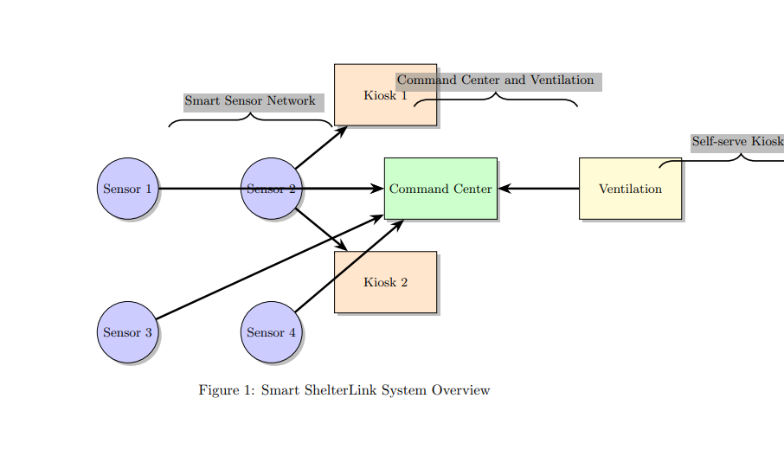

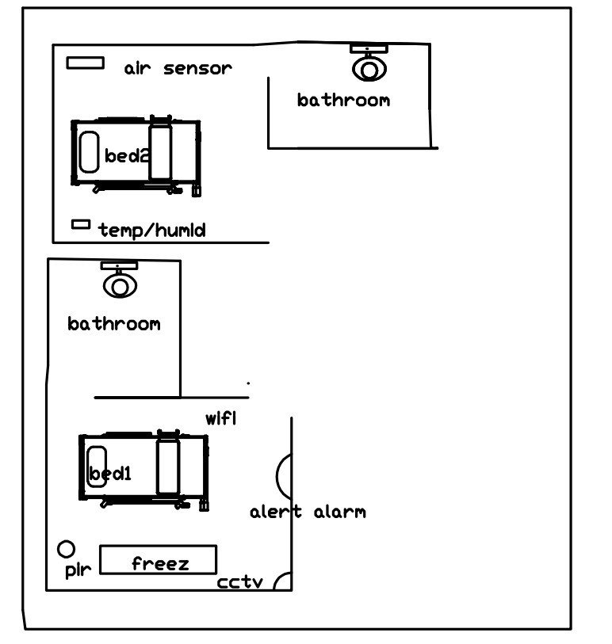

8. SUMMARY OF THE FIGURES / DIAGRAMS / DRAWINGS with the explanation of all parts in the drawing and how it works.

- Smart Sensor Network:
  - Components: Four smart sensors (Sensor 1, Sensor 2, Sensor 3, Sensor 4).
  - Representation: Circular shapes filled with blue color.
  - Explanation: These sensors monitor real-time data, including occupancy, temperature, humidity, and air quality within the shelter.
- Command Center:
  - Component: Centralized command center.
  - Representation: Rectangular shape filled with green color.
  - Explanation: The central hub for data collection, analysis, and decision-making. It receives real-time data from sensors, enabling comprehensive oversight.
- Ventilation System:
  - Component: Ventilation system.
  - Representation: Rectangular shape filled with yellow color.
  - Explanation: This system ensures optimal air quality within the shelter, equipped with filters and mechanisms for maintaining a healthy environment.
- Self-serve Kiosks:
  - Components: Two self-serve kiosks (Kiosk 1, Kiosk 2).
  - Representation: Rectangular shapes filled with orange color.
  - Explanation: Placed strategically within the shelter, these kiosks provide evacuees with real-time updates on shelter capacity, available resources, and local information.
- Arrows:
  - Representation: Arrows with a line width of 1.5pt.
  - Explanation: Arrows indicate the flow of information between the sensors, command center, ventilation system, and kiosks, representing the interconnected nature of the ShelterLink system.
- Annotations:
  - Representation: Brace-shaped annotations with explanatory text.
  - Explanation: Braces provide additional context, grouping the components into sections for better understanding. They categorize the Smart Sensor Network, Command Center and Ventilation, and Self-serve Kiosks.

9. ABSTRACT (150 words)
Option 1: Emphasizing Evacuee Experience
ShelterLink is a revolutionary network designed to transform disaster evacuation shelters. It uses a network of sensors, self-serve kiosks, and data-driven management to combat overcrowding, resource scarcity, and limited information. ShelterLink prioritizes evacuee health by monitoring air quality and facilitating social distancing. Real-time data ensures supplies are distributed equitably, while information kiosks empower evacuees with knowledge during difficult times. ShelterLink reimagines shelters as safe havens, offering efficiency, organization, and a focus on well-being.
Option 2: Focusing on Technology & Innovation
ShelterLink modernizes traditional disaster shelters using cutting-edge IoT technology. A network of smart sensors tracks real-time occupancy, air quality, and critical environmental data, enabling proactive resource allocation and maximizing shelter efficiency. Self-serve kiosks keep evacuees informed, reducing chaos and anxiety. Centralized data analysis empowers disaster response teams to make informed, data-driven decisions. ShelterLink exemplifies the power of technology to address humanitarian crises, prioritizing the safety, health, and well-being of those displaced during emergencies.
Option 3: Highlighting Proactive Public Health
ShelterLink redefines the evacuation shelter experience, prioritizing preventative public health measures. Real-time air quality monitoring and advanced ventilation systems minimize the risk of airborne disease transmission, a critical concern during pandemics. Designated areas facilitate social distancing, further protecting evacuees. ShelterLink employs smart sensors to track occupancy, ensuring equitable resource distribution and preventing overcrowding. Informational kiosks reduce confusion and empower evacuees with up-to-date local news and resource availability. ShelterLink places evacuee health and safety at the forefront of disaster response.

10. BRIEF DETAIL OF PARTS OF THE DEVICE, APPARATUS, PRODUCT IN BULLET POINTS – In case the invention is related to product, device and apparatus.
Essential Hardware Components-

- Smart Sensor Network:
  - Occupancy Sensors: Placed at shelter entrances/exits. Could use infrared, motion detection, computer vision, etc., to count people and track capacity in real-time.
  - Temperature and Humidity Sensors: Monitor indoor comfort levels, helping adjust ventilation as needed. Important for health and safety.
  - Air Quality Sensors: Detect levels of particulate matter, VOCs (volatile organic compounds), carbon dioxide, etc. Crucial for identifying and maintaining healthy air quality.

- Ventilation and Air Circulation System:
  - Air Intake & Exhaust: Strategically placed for optimal airflow within the shelter.
  - HEPA Filters: Capture particulate matter, reducing pollutants and improving air quality.
  - UV Light Disinfection: Option to inactivate potential airborne pathogens, further protecting evacuees.
  - Airflow Control: System dynamically adjusts intake/exhaust fans and dampers based on real-time data (occupancy, air quality).

- Self-Serve Information Kiosks
  - Touchscreen Display: Intuitive interface for users to view up-to-date information and resources.
  - Computer/Processing Unit: Runs the kiosk software, connected to the ShelterLink network for real-time data updates.
  - Network Connectivity: Wired or wireless connection to the ShelterLink central data system.
  - Accessibility Features: Screen reader compatibility, large fonts, high contrast modes to serve individuals with disabilities.

- Central Command Center
  - High-Performance Computers: Process large amounts of data from multiple shelters.
  - Data Visualization Dashboard: Software that clearly presents insights, trends, and alerts to disaster management teams.
  - Network Hub: Secure connection to all shelters for data transmission.
  - Communication Systems: Allow for coordination, alerts, and decision-making across teams.

***Note: Explain the Parts of the Device***

11. BRIEFLY EXPLAIN THE STEPS, FLOW CHART, FUNCTIONALITY OF INVENTION RELARED TO SOFTWARE EMBEDDED WITH MACHINE, DEVICE, APPRATUS.
***Note: Explain the functionality of software embedded with the device***

Software Functionality - Shelter Link System

1. Activation during Emergencies:
- The software is activated when an emergency or disaster is declared.
- Initiates real-time data collection from the smart sensor network.

2. Data Collection and Processing:
- Aggregates data from sensors, including occupancy, temperature, humidity, and air quality.
- Cleanses and validates the data for accuracy and reliability.

3. Resource Allocation and Optimization:
- Utilizes advanced analytics and machine learning algorithms to optimize resource allocation.
- Considers factors like shelter occupancy levels, resource availability, and predicted demand.

4. Evacuation and Shelter Management:
- Monitors real-time shelter capacities and occupancy levels.
- Integrates with external data sources (weather forecasts, transportation systems) for efficient evacuation planning.
- Coordinates shelter assignments based on capacity and real-time conditions.

5. Information Dissemination:
- Integrates seamlessly with self-serve information kiosks.
- Updates kiosks with real-time information on shelter capacity, available resources, local updates, and assistance programs.
- Facilitates the dissemination of critical information to disaster response teams for effective coordination.

6. User Interface and Accessibility:
- Provides user-friendly interfaces for evacuees (via kiosks) and disaster response teams (via command center displays).
- Supports multiple languages and includes accessibility features (screen readers, high-contrast modes) for inclusivity.
- Designed to be intuitive and easy to navigate, minimizing the learning curve during emergencies.

7. Continuous Monitoring and Adjustment:
- Continuously monitors shelter operations based on real-time data.
- Adjusts resource allocation, evacuation plans, and shelter assignments dynamically as the situation evolves.

8. Post-event Analysis and Refinement:
- Conducts post-event analysis to evaluate the system's performance.
- Refines algorithms based on insights gained for continuous improvement

Software Flow Chart (Simplified):

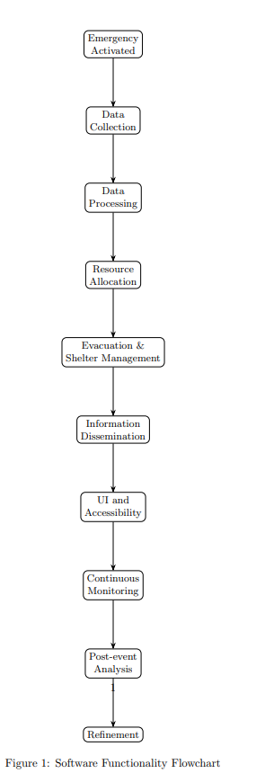

This flow chart illustrates the sequential steps and interactions within the software embedded in the ShelterLink system. From emergency activation to continuous refinement, the software plays a vital role in ensuring the efficient and effective management of smart shelters during disasters.

12. BRIEFLY EXPLAIN THE STEPS OF PROCESS, COMPOSITION IN BULLET POINTS – In case the invention is related to process, composition.
***Note: Ignore it if the invention is not related to process, composition***

Since the ShelterLink invention is focused on a system and apparatus for smart shelters, rather than a specific process or chemical composition, this section is not directly applicable. However, I can provide a brief overview of the process or workflow involved in the deployment and operation of the ShelterLink system:

Deployment Process:

• Site selection and preparation for shelter facilities
• Installation of the smart sensor network (occupancy, environmental, and air quality sensors)
• Integration of the ventilation and air circulation system
• Set up of self-serve information kiosks
• Establishment of the central command center with computing infrastructure
• Configuration and testing of the software components

Operational Workflow:

• Activation of the ShelterLink system during a disaster or emergency situation
• Real-time data collection from the sensor network across shelter locations
• Data processing, analysis, and application of predictive models
• Optimization of resource allocation based on occupancy levels and demand forecasts
• Updating of self-serve kiosks with latest information (capacity, resources, updates)
• Dissemination of critical information to disaster response teams
• Continuous monitoring and adjustment of shelter operations based on real-time data
• Coordination of evacuation and shelter assignments based on capacity and conditions
• Post-event analysis and refinement of algorithms for future improvements

13. RELATED PUBLICATION (If Any)

14. SCANNED SIGNATURE



